**P615/4**

**ART**

**STUDY OF ART**

**Paper 4**

**Jul/Aug 2016**

2 ½ hours

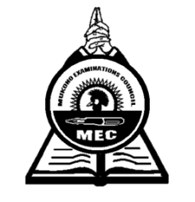

**MUKONO EXAMINATIONS COUNCIL**

**Uganda Advanced Certificate of Education**

**ART STUDIO TECHNOLOGY**

Paper 4

2 hours 30 minutes

**INSTRUCTIONS TO CANDIDATES:**

*This paper contains***ten***questions.*

*Answer* ***all*** *the ten questions.*

*Drawings and diagrams should be used where necessary.*

1. Explain how the following apply to Art and Design;

(a). Palette ***(02marks)***

(b). Saturation ***(02marks)***

(c) Hierarchy ***(02marks)***

(d). Tint ***(02marks)***

2. (a). Define the term perspective ***(03marks)***

(b). Differentiate between Aerial and Linear perspective ***(04 marks)***

3. (a) What is sculpture? ***(03marks)***

(b).With illustrations discuss any three types of sculpture ***(03marks)***

4. (a) Explain any three types of clay  ***(03marks)***

(b) Why is glaze an important material in Art ***(04 marks)***

5. Discuss the following terms:

(i). Leather hard  ***(03 mark)***

ii). Bone dry ***(03 mark)***

6 a) Describe three styles followed when making Tie and Dye ***(03marks)***

b) Discuss two delimitations of Tie and Dye as a decoration technique in textile design

***(02marks)***

7. (a) Define the term Serigraphy as used in Art ***(03marks)***

(b) What substance is added to printing paste to make it permanent? ***(03marks)***

8. (a) Define the term spinning ***(03 marks)***

(b) Mention two types of fibres ***(02 marks)***

1. (a) List down six Products made out of leather ***(06 marks)***

(b) Discuss the process of producing Leather ***(06 marks)***

1. Explain the following:

(a) Sigrafitto (b) Slip trailing (c) Burnishing (d) Engobe ***(08 marks)***

**END**